**Regulatory Sites**

**Accordion Menu Solution Guide**

Contents

Accordion Menu Content Type 3

Content Type Design 3

Creating the Content Type 3

Creating the List Template 7

Navigation List 10

Create the Navigation List 10

Open the Accordion Navigation List in SharePoint Designer 12

Remove the Extra Save and Cancel Button in the New Form 15

Remove the * After Menu Item Title in the New Form 17

Remove the Extra Save and Cancel Button in the Edit Form 18

Remove the * After Menu Item Title in the Edit Form 20

New Item Page 21

Create the Set Sequence Levels Web Part 21

Create the Validation Web Part 25

Create the User Guide Web Part 30

Create the Form Examples Web Part 32

Move the Code Web Parts to the Bottom of the Page 35

Test the New Form Page 37

Edit Item Page 41

Create a New Item 41

Create the Validation Web Part 42

Create the User Guide Web Part 47

Create the Form Examples Web Part 49

Move the Code Web Part to the Bottom of the Page 52

Test the Edit Form Page 53

Deploy the Custom Master Page 56

Create the Custom Master Page 56

Deploy the Custom Master Page 77

Configure the Accordion Menu 78

Remove the Standard Navigation (Optional Step) 79

# Accordion Menu Content Type

Content Type Design

|  |  |  |
| --- | --- | --- |
| Name | Type | Default Values |
| Title | Single Line of Text | N/A |
| Level | Choice | 1,2 |
| LVL1Sequence | Choice | 0,1,2,3,4,5,6,7,8,9,10,11,12,13,14,15 |
| LVL2Sequence | Choice | 0,1,2,3,4,5,6,7,8,9,10,11,12,13,14,15 |
| TopItemID | Choice | 0,1,2,3,5,6,7,8,9,10,11,12,13,14,15 |
| Link | Single Line of Text | N/A |

Creating the Content Type

1. Note: The following steps require Site Collection Admin permissions
2. From the site’s home page click on the Site Action Cog and from the drop down click on the “Site Settings” link

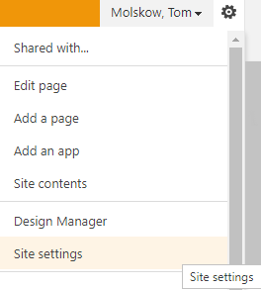

1. From the Site Settings page, Web Designer Galleries header section, click on the “Site Content Types” link

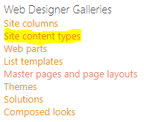

1. From the Site Content Types page click on the “Create” button



1. From the “New Site Content Type” page make the following configurations:

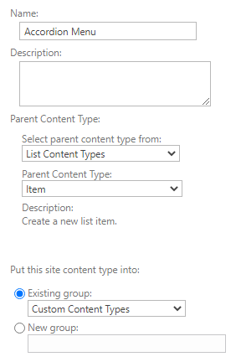

* 1. Name: Accordion Menu
  2. Parent Content Type From: List Content Type
  3. Parent Content Type: Item
  4. Existing Group: Custom Content Types

1. Click the “OK” button (this will bring you to the Site Content Type page)
2. From the Site Content Type page scroll down to the Columns area and click on the “Add from new site column page”

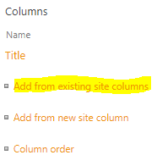

1. You will rename the “Title” field to “Menu Item Field”
2. You will create the following Site Columns with the following configurations:
   1. Level
      1. Column Name: Level
      2. Column Type: Choice
      3. Group: Custom Columns
      4. Description: All Items, 1 - Top Level Menu Item, 2 - Second Level Menu Item
      5. Require that this Column Contains Information: No
      6. Enforce Unique Values: No
      7. Type Each Choice on a Separate Line: 1,2
      8. Display Choices Using: Drop Down
      9. Allow Fill-in Choices: No
      10. Default Value: None
   2. LVL1Sequence
      1. Column Name: LVL1Sequence
      2. Column Type: Choice
      3. Group: Custom Columns
      4. Description: Level 1 Items Only, The Item's Sequence Order
      5. Require that this Column Contains Information: No
      6. Enforce Unique Values: No
      7. Type Each Choice on a Separate Line: 0,1,2,3,4,5,6,7,8,9,10,11,12,13,14,15
      8. Display Choices Using: Drop Down
      9. Allow Fill-in Choices: No
      10. Default Value: 0
   3. LVL2Sequence
      1. Column Name: LVL2Sequence
      2. Column Type: Choice
      3. Group: Custom Columns
      4. Description: Level 2 Items Only, The Item's Sequence Order
      5. Require that this Column Contains Information: No
      6. Enforce Unique Values: No
      7. Type Each Choice on a Separate Line: 0,1,2,3,4,5,6,7,8,9,10,11,12,13,14,15
      8. Display Choices Using: Drop Down
      9. Allow Fill-in Choices: No
      10. Default Value: 0
   4. TopItemID
      1. Column Name: TopItemID
      2. Column Type: Choice
      3. Group: Custom Columns
      4. Description: Level 2 Items Only, The Level 1 Item that this Level 2 Item Will Appear Under
      5. Require that this Column Contains Information: No
      6. Enforce Unique Values: No
      7. Type Each Choice on a Separate Line: 0,1,2,3,4,5,6,7,8,9,10,11,12,13,14,15
      8. Display Choices Using: Drop Down
      9. Allow Fill-in Choices: No
      10. Default Value: 0
   5. Link
      1. Column Name: Link
      2. Column Type: Single Line of Text
      3. Group: Custom Columns
      4. Description: Level 2 Items Only, The Level 2 Menu Item's Hyperlink
      5. Require that this Column Contains Information: No
      6. Enforce Unique Values: No
      7. Maximum number of Characters: No
      8. Default Value: None
3. Once all the Custom Columns have been created return to the Site Content Types page.

Creating the List Template

1. Note: The following steps require Site Collection Admin permissions
2. From the Home page click on the Site Actions Cog and from the drop down choose Site Contents

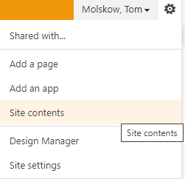

1. From the Site Contents page click on the “Add an App” icon



1. From the “Your Apps” page click on the “Custom List” icon, a pop-up dialog box will appear

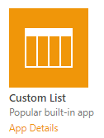

1. In the pop-up dialog enter the name “Accordion Menu” and click the “Create” button, this will return you to the Site Contents page

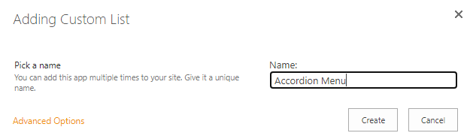

1. From the Site Contents page click on the “Accordion Menu” list icon

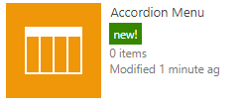

1. From the Accordion Menu list page, in the ribbon, click on the “List” tab



1. In the “List” tab ribbon click on the “List Settings” icon



1. From the list Settings page click in the General Settings column, click on the “Advanced Settings” link



1. From the Advanced Settings click “Yes” on the “Allow management of content types”, and then click the “OK” button



1. Back at the “Settings” page, scroll down to the Content Type section and click on the “Add from existing content type links”

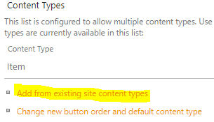

1. From the “Add Content Types” page, from the “Available Site Content Types” choose the “Accordion Menu” content type and click the “Add” button, and then click the “OK” button

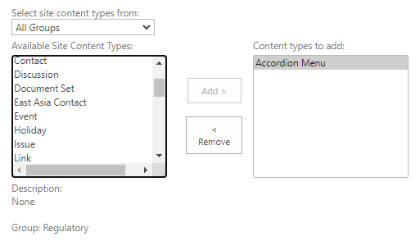

1. From Accordion Navigation settings page scroll down to the “Column” section

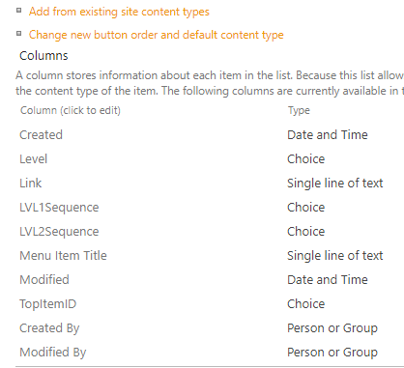

1. Now back at the Settings page, in the “Permissions and Management” column click on the “Save list as template” link



1. In the “Save as Template” make the following configurations and then click the “OK” button

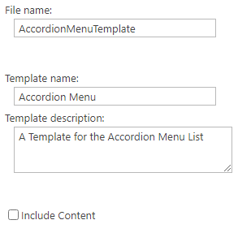

* 1. File Name: AccordionMenuTemplate
  2. Template Name: Accordion Menu
  3. Template Description: A Template for the Accordion Menu List

1. From the “Operation Completed Successfully” page click “OK”
2. Navigate back to the Site Contents page and you should see the new Accordion Menu icon now available for creating new Accordion Menu lists

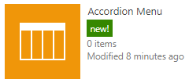

# Navigation List

Create the Navigation List

1. Open the “Top Site” of the Site Collection or Site, Example:

“Wyoming” - <https://bentest.bhcorp.ad/sites/regulatory3/wyoming/Pages/default.aspx>

1. Click on the Site Action Cog, and from the Drop-Down Menu choose “Site Contents”
2. From the Site Contents page, click on the “Add an app” icon



1. From the “Your Apps” page, click on the “Accordion Navigation” list template

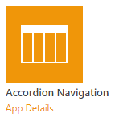

1. From the pop-up menu, in the Name section, name the new list “Accordion Navigation”, and then click on the “Create” button

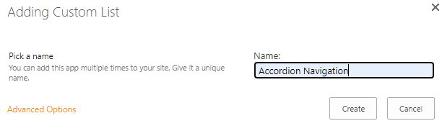

1. This will create the “Accordion Navigation” list, click on the list icon to open the list



1. Click on this icon (this will open the Accordion Navigation List)
2. From the Accordion Navigation list, in the left portion of the Ribbon Menu, click on the “List” tab

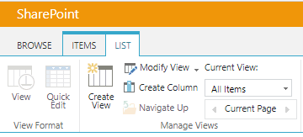

1. From the “List” tab interface, on the far right, in the “Settings” section, click on the “List Settings” icon

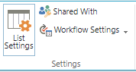

1. Back at the Settings page scroll down to the Content Types section, and then click on the “Change new button order and default content type” link

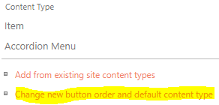

1. From the “Change New Button Order Page” click off the “Visible” setting for the “Item” content type and click on the content type



1. From the Column section, click on the Column named “LVL1Sequence”, this will open the LVL1Sequence column’s configuration page



1. From the LVL1Sequence column’s configuration page change the column name to “Level 1 Sequence”, and then click the “OK” button, this will return you to List Settings Page



1. Back at the list settings page, click on the Column named “LVL2Sequence”, this will open the LVL2Sequence column’s configuration page



1. From the LVL2Sequence column’s configuration page change the column name to “Level 2 Sequence”, and then click the “OK” button, this will return you to List Settings Page



1. Back at the list settings page, click on the Column named “TopItemID”, this will open the TopItemID column’s configuration page



1. From the TopItemID column’s configuration page change the column name to “Top Item ID”, and then click the “OK” button, this will return you to List Settings Page



Open the Accordion Navigation List in SharePoint Designer

1. From the desktop, click on the SharePoint Designer icon



1. From the Sites menu, in the larger right panel, click on the “Open Site” button

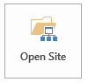

1. From the “Open Sites” pop-up menu, in the “Site Name” field, input the name of the site you are working on (in this example we will use the Wyoming site), and then click the “Open” button

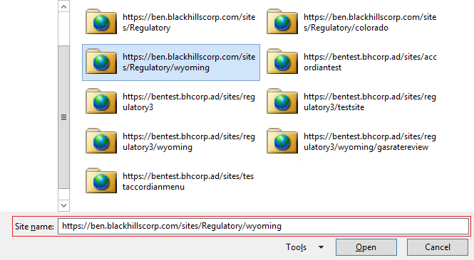

1. In the SharePoint Designer sites interface, in the “Navigation” panel (on the left), click on the “Lists and Libraries” menu item (this will open the Lists and Libraries navigation tab on the right)

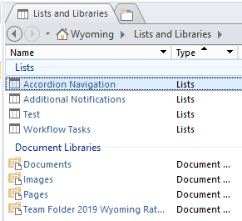

1. In the Lists and Libraries tab, click on the “Accordion Navigation” list menu item link, this will open the Accordion Navigation list interface

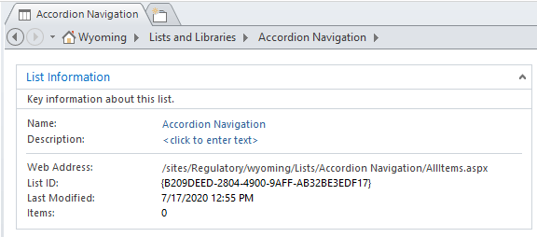

1. From the Accordion Navigation list interface, in the “Forms” section click on the “New” button

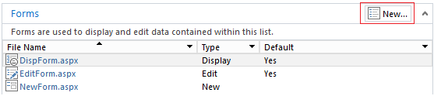

1. From the Create New List Form pop-up menu, make the following configurations:
   1. File Name: NewForm1
   2. New Item Form
   3. Set as default form for the selected type
   4. Select the Content Type to use: Accordion Menu

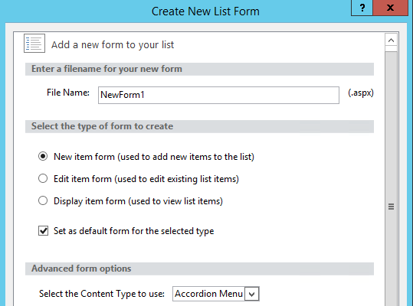

1. Now click the “OK” button (this will close the pop-up menu and return you to the Accordion Navigation list interface
2. Again, from the Accordion Navigation list interface, in the “Forms” section, click on the “New” button



1. From the Create New List Form pop-up menu, make the following configurations:
   1. File Name: EditForm1
   2. Edit Item Form
   3. Set as default form for the selected type
   4. Select the Content Type to use: Accordion Menu

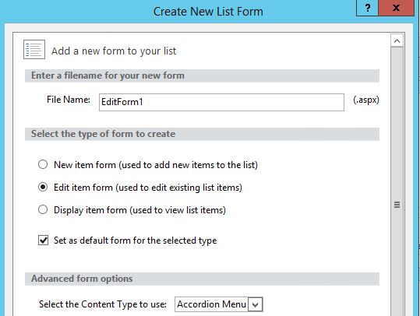

Remove the Extra Save and Cancel Button in the New Form

1. Note: Depending on the site, this step may not be necessary
2. Again, from the Accordion Navigation list interface on the right in the “Forms” panel, click on the NewForm1.aspx form link (this will open the NewForm1.aspx editing interface)

,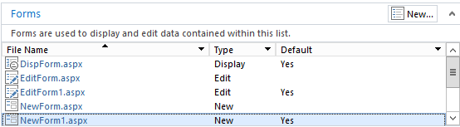

1. From the NewForm1.aspx editing interface, in the right side of the tool ribbon, click on the “Advanced Mode” button (this will put the form in Advanced Editing Mode)



1. With NewForm1.aspx form in advanced editing mode scroll down (or search) until you find the code section below:

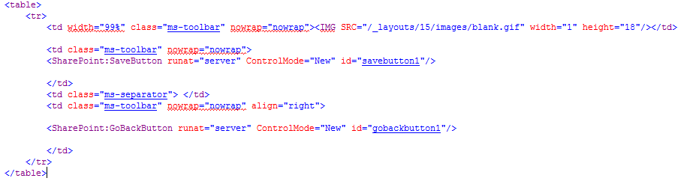

1. Modify the code above by adding HTML comments markup (<!-- -->) before the opening <table> tag and after the closing </table> tag, so it appears as seen below:

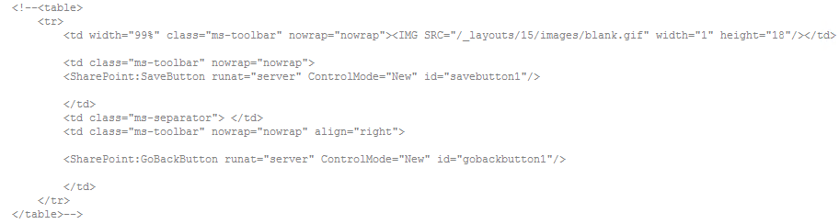

1. Now still in the same interface, in the top left menu ribbon, click the “Save” button



1. To test your changes, in the top left menu ribbon, click on the “Preview in Browser” button (this will open the form in a separate browser window)



1. In this Preview you should now see that the form has only one set “Save” and “Cancel” buttons (not two as previously)

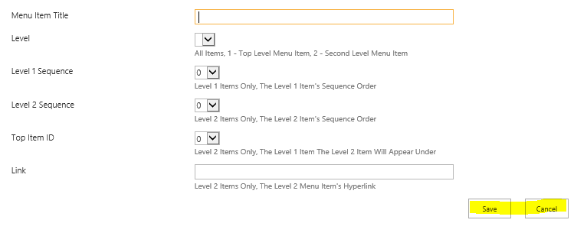

Remove the * After Menu Item Title in the New Form

1. Note: Depending on the site, this step may not be necessary
2. With NewForm1.aspx form still in Advanced Editing Mode scroll down until you find the code section below or you can search on the phrase “Menu Item Title”:

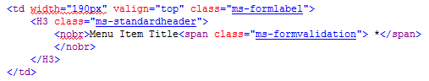

1. Now remove the “*” that appears right after the “class=’ms-formvalidation’> “ text, so the new line appears as below:

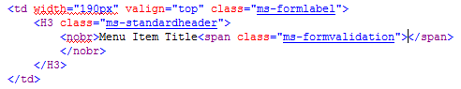

1. Now still in the same interface, in the top left menu ribbon, click the “Save” button



1. To test your changes, in the top left menu ribbon, click on the “Preview in Browser” button (this will open the form in a separate browser window)



1. In this Preview you should now see that the Menu Item Title” field no longer has an “*” after its title

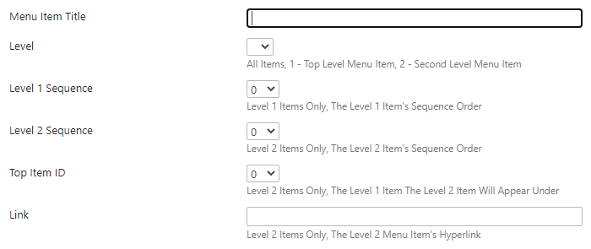

Remove the Extra Save and Cancel Button in the Edit Form

1. From the Accordion Navigation list management page, on the right in the “Forms” panel, click on the EditForm1.aspx form link (this will open the NewForm1.aspx editing interface)

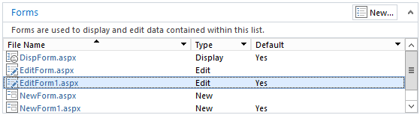

1. From the NewForm1.aspx editing interface, in the right side of the tool ribbon, click on the “Advanced Mode” button (this will put the form in Advanced Editing Mode)



1. With EditForm1.aspx form in Advanced Editing Mode scroll down (or search) until you find the code section below:



1. Modify the code above by adding HTML comments markup (<!-- -->) before the opening <table> tag and after the closing </table> tag, so it appears as seen below:



1. Now still in the same interface, in the top left menu ribbon, click the “Save” button



1. To test your changes, in the top left menu ribbon, click on the “Preview in Browser” button (this will open the form in a separate browser window)



1. In this Preview you should now see that the form has only one set “Save” and “Cancel” buttons (not two as previously)



Remove the * After Menu Item Title in the Edit Form

1. With EditForm1.aspx form still in Advanced Editing Mode scroll down (or search) until you find the code section below (should be near line 167):



1. Now remove the “*” that appears right after the “class=’ms-formvalidation’> “ text, so the new line appears as below:



1. Now still in the same interface, in the top left menu ribbon, click the “Save” button



1. To test your changes, in the top left menu ribbon, click on the “Preview in Browser” button (this will open the form in a separate browser window)



1. In this Preview you should now see that the Menu Item Title” field no longer has an “*” after its title

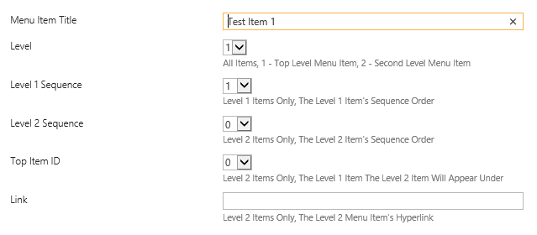

# New Item Page

Create the Set Sequence Levels Web Part

1. From the Accordion Navigation list, click on the “New Item” link



1. This will open the “NewForm1” or “New Item” page

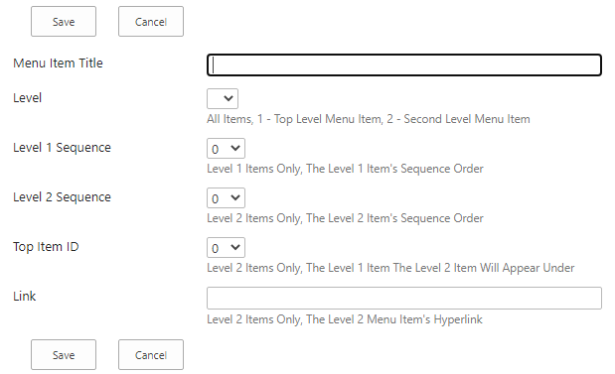

1. From the New Item page click on the Site Actions cog and from the drop-down choose “Edit Page”, this will open the New Item page in the Page Edit Mode

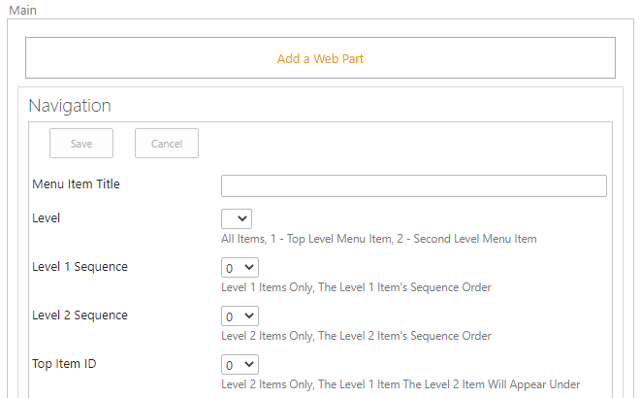

1. With the New Item page in the Edit Mode click on the “Add a Web Part” link, this will open the “Add a Web Part” interface, and then in the “Categories” panel on the left, scroll down and click on the “Media and Content” link, and then from the “Parts” panel on the right choose “Content Editor”

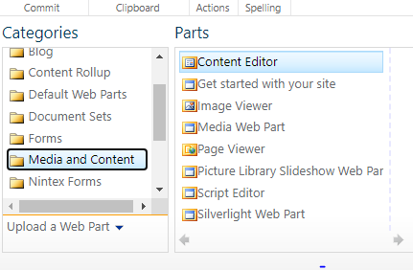

1. From the right-hand side of the Add a Web Part interface and click on the “Add” button (this will add the Content Editor Web Part” to the New Item page

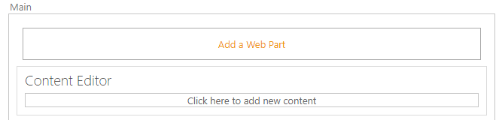

1. From the new Content Editor Web Part, click on the drop down arrow (sometimes only visible when you click anywhere in the left side of the web part) and from the drop down menu click on the “Edit Web Part” link

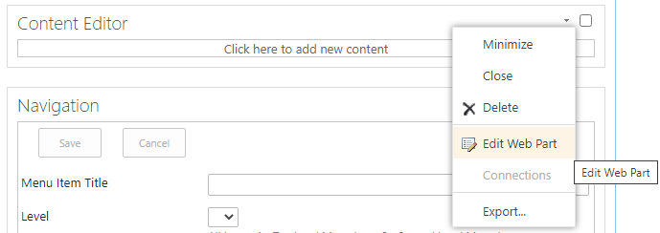

1. This will open the Content Editor Web Part Configuration Menu (displays on the right)

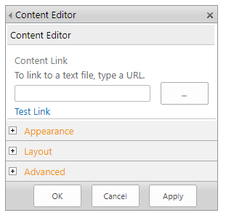

1. In the Content Editor Web Part Configuration Menu click on the “Appearance” Menu item, and in the Appearance panel make the following configurations:
   1. Title: Set Sequence Levels
   2. Chrome Type: None
2. Finally scroll down and click on the “OK” button (this will save the changes you made)
3. Now click in the Content Editor Web Part (which now has the title “Set Sequence Levels”), click where you see the words “Click here to add new content”



1. Now from the menu click on the “Edit Source” button, this will open a window for adding HTML and JavaScript Source Code



1. In the HTML Source window, past the code below:

<script language="javascript" src="/sites/Regulatory/SiteAssets/JavaScript/jquery-1.11.3.min.js"></script>

<script language="javascript" src="/sites/Regulatory/SiteAssets/JavaScript/jquery.SPServices-2014.02.js"></script>

<script language="javascript">

$(function () {

$.ajax({

url: "/gas-engineering/_api/web/lists/GetByTitle('Accordion Navigation')/items?",

type: "GET",

headers: {

"accept": "application/json;odata=verbose"

},

}).success(function (data) {

var arrayLVL1Sequence = []; // An Array to Hold All the LVL1Sequence Values

var arrayLVL2Sequence = []; // An Array to Hold All the LVL2Sequence Values

//alert("test 1");

$.each(data.d.results, function (key, value) {

//Level Sequence Variables

var vLVL1Sequence = value.LVL1Sequence;

var vLVL2Sequence = value.LVL2Sequence;

//alert("vLVL1Sequence " + vLVL1Sequence + " vLVL2Sequence " + vLVL2Sequence); //For Testing Only

//LVL1Sequence

if (vLVL1Sequence != null){

arrayLVL1Sequence.push(vLVL1Sequence); }

arrayLVL1Sequence.sort();

//LVL2Sequence

if (vLVL2Sequence != null){

arrayLVL2Sequence.push(vLVL2Sequence); }

arrayLVL2Sequence.sort();

});

//Update Level 1 Sequence

var lastItemLVL1 = arrayLVL1Sequence.pop();

lastItemLVL1 = parseInt(lastItemLVL1) + 1;

var selLVL1 = $("select[title='LVL1Sequence']").val(lastItemLVL1);

//alert("selLVL1: " + selLVL1.value); //For Testing Only

//Update Level 2 Sequence

var lastItemLVL2 = arrayLVL2Sequence.pop();

lastItemLVL2 = parseInt(lastItemLVL2) + 1;

var selLVL2 = $("select[title='LVL2Sequence']").val(lastItemLVL2);

//alert("selLVL2: " + selLVL2); //For Testing Only

failure(function (data) {

alert("Failure");

});

});

});

</script>

1. In the highlighted section of code, change the URL you see there to the URL for your site, for example:

a. Example Code: /sites/Regulatory/colorado/

b. Your site’s URL: <https://ben.blackhillscorp.com/sites/Regulatory/wyoming/>

c. Updated Code: /sites/Regulatory/wyoming/

1. Now click on the “OK” button (this will save the added code)

Create the Validation Web Part

1. With the New Item page in the Edit Mode click on the “Add a Web Part” link, this will open the “Add a Web Part” interface, and then in the “Categories” panel on the left, scroll down and click on the “Media and Content” link, and then from the “Parts” panel on the right choose “Content Editor”



1. From the right-hand side of the Add a Web Part interface and click on the “Add” button (this will add the Content Editor Web Part” to the New Item page



1. From the new Content Editor Web Part, click on the drop down arrow (sometimes only visible when you click anywhere in the left side of the web part) and from the drop down menu click on the “Edit Web Part” link



1. This will open the Content Editor Web Part Configuration Menu (displays on the right)



1. In the Content Editor Web Part Configuration Menu click on the “Appearance” Menu item, and in the Appearance panel make the following configurations:
   1. Title: Validation
   2. Chrome Type: None
2. Finally scroll down and click on the “OK” button (this will save the changes you made)
3. Now click in the Content Editor Web Part (which now has the title “Validation”), click where you see the words “Click here to add new content”

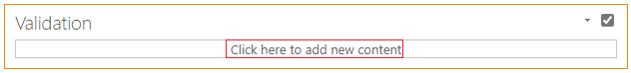

1. Now from the menu click on the “Edit Source” button, this will open a window for adding HTML and JavaScript Source Code



1. In the HTML Source window, past the code below:

<script language="javascript" src="/sites/Regulatory/SiteAssets/JavaScript/jquery-1.11.3.min.js"></script>

<script language="javascript" src="/sites/Regulatory/SiteAssets/Menu/jquery.SPServices-2014.02.js"></script>

<script language="javascript">

_spBodyOnLoadFunctionNames.push("validate"); {

}

function PreSaveAction() {

//*** Title

var strTitle = $("input[title='Menu Item Title Required Field']").val();

//*** Level

var ddlLevel = $("select[title='Level'] option:selected").text();

//*** Level 1 Sequence

var ddlLvl1Sequence = $("select[title='LVL1Sequence'] option:selected").text();

//*** Level 2 Sequence

var ddlLvl2Sequence = $("select[title='LVL2Sequence'] option:selected").text();

//*** Top Item ID

var ddlTopItemID = $("select[title='TopItemID'] option:selected").text();

//*** Link

var strLink = $("input[title='Link']").val();

return validateForm();

function validateForm(){

//*** General Validations: Ensure a Level Has Been Selected

if(ddlLevel == "1" || ddlLevel == "2"){

} else {

//alert("Level: You must choose a Level");

}

//*** Validate: If Level 2 Item

if(ddlLevel == "2") {

var valTitle2 = "";

var valLink2 = "";

var valLvl1Sequence2 = "";

var valLvl2Sequence2 = "";

var valTopItemID2 = "";

var errorMsg = "";

//The Title Field Cannot be Empty

if(strTitle == "") {

errorMsg += "Menu Item Title: You must provide a Title\n\n";

valTitle2 = "false";

} else {

valTitle2 = "true";

}

//The Level 1 Sequence Field Value Should Be Zero

if(ddlLvl1Sequence == "0") {

valLvl1Sequence2 = "true";

} else {

errorMsg += "Level 1 Sequence: You have chosen to create a Level 2 Item; the Level 1 Sequence should be Zero\n\n";

valLvl1Sequence2 = "false";

}

//The Level 2 Sequence Must Not be Zero

if(ddlLvl2Sequence == "0") {

errorMsg += "Level 2 Sequence: You have chosen to create a Level 2 menu item; the Level 2 Sequence must not be set to Zero\n\n";

valLvl2Sequence2 = "false";

} else {

valLvl2Sequence2 = "true";

}

//The Top Item ID Must be Zero

if(ddlTopItemID == "0") {

errorMsg += "Top Item ID: You have chosen to create a Level 2 menu item; the Top Item ID must not be set to Zero\n\n";

valTopItemID2 = "false";

} else {

valTopItemID2 = "true";

}

//The Link Field Should Not Be Empty

if(strLink == "") {

errorMsg += "Link: You have chosen to create a Level 2 Item; you must provide a Link\n\n";

valLink2 = "false";

} else {

valLink2 = "true";

}

//Check All Validations and If All True Return True

if(valLink2 == "true" && valLvl1Sequence2 == "true" && valLvl2Sequence2 == "true" && valTopItemID2 == "true" && valTitle2 == "true") {

return true;

} else {

alert(errorMsg);

return false;

}

}

//*** Validate: If Level 1 Item

if(ddlLevel == "1") {

valTitle1 = "";

var valLink1 = "";

var valLvl1Sequence1 = "";

var valLvl2Sequence1 = "";

var valTopItemID1 = "";

var errorMsg = "";

//The Title Field Cannot be Empty

if(strTitle == "") {

errorMsg += "Menu Item Title: You must provide a Title\n\n";

valTitle1 = "false";

} else {

valTitle1 = "true";

}

//The Level 1 Sequence Field Value Should Not Be Zero

if(ddlLvl1Sequence == "0") {

errorMsg += "Level 1 Sequence: You must select a Level 1 Sequence value greater than Zero\n\n";

valLvl1Sequence1 = "false";

} else {

valLvl1Sequence1 = "true";

}

//The Level 2 Sequence Must be Zero

if(ddlLvl2Sequence == "0") {

valLvl2Sequence1 = "true";

} else {

errorMsg += "Level 2 Sequence: You have chosen to create a Level 1 menu item; the Level 2 Sequence must be set to Zero\n\n";

valLvl2Sequence1 = "false";

}

//alert("ddlLvl2Sequence " + ddlLvl2Sequence);

//The Top Item ID Must be Zero

if(ddlTopItemID == "0") {

valTopItemID1 = "true";

} else {

errorMsg += "Top Item ID: You have chosen to create a Level 1 menu item; the Top Item ID must be set to Zero\n\n";

valTopItemID1 = "false";

}

//The Link Field Should Be Empty

if(strLink == "") {

valLink1 = "true";

} else {

errorMsg += "Link: You have chosen to create a Level 1 Item; the Link field must be empty\n\n";

valLink1 = "false";

}

//Check All Validations and If All True Return True

if(valLink1 == "true" && valLvl1Sequence1 == "true" && valLvl2Sequence1 == "true" && valTopItemID1 == "true" && valTitle1 == "true") {

return true;

} else {

alert(errorMsg);

return false;

}

}

}

}

</script>

1. Now click on the “OK” button (this will save the added code)

Create the User Guide Web Part

1. From the New Item page click on the Site Actions cog and from the drop-down choose “Edit Page”, this will reopen the New Item page in the Edit Mode

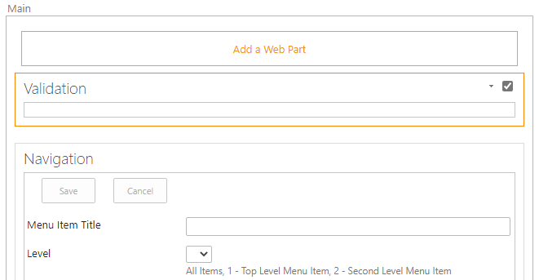

1. From the Edit Mode click on the “Add a Web Part” link, this will open the “Add a Web Part” interface, and then in the “Categories” panel on the left, scroll down and click on the “Media and Content” link, and then from the “Parts” panel on the right choose “Content Editor”



1. From the right-hand side of the Add a Web Part interface and click on the “Add” button (this will add another Content Editor Web Part” to the New Item page



1. From the new Content Editor Web Part, click on the drop down arrow (sometimes only visible when you click anywhere in the left side of the web part) and from the drop down menu click on the “Edit Web Part” link



1. This will open the Content Editor Web Part Configuration Menu (displays on the right)



1. In the Content Editor Web Part Configuration Menu click on the “Appearance” Menu item, and in the Appearance panel make the following configurations:
   1. Title: User Guide
   2. Chrome Type: None
2. Finally scroll down and click on the “OK” button (this will save the changes you made)
3. Now click in the Content Editor Web Part (which now has the title “User Guide”), click where you see the words “Click here to add new content”

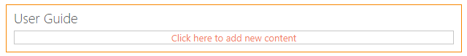

1. Now from the menu click on the “Edit Source” button, this will open a window for adding HTML and JavaScript Source Code



1. In the HTML Source window, past the code below:

<h4><a href="https://ben.blackhillscorp.com/sites/Regulatory/Development%20Team%20Docs/SharePoint%20Regulatory%20Accordion%20Menu%20List%20%E2%80%93%20User%20Guide.docx?Web=1">Click Here to See the User&#39;s Guide</a>

</h4>

1. Now click on the “OK” button (this will save th added code)

Create the Form Examples Web Part

1. From the New Item page click on the Site Actions cog and from the drop-down choose “Edit Page”, this will reopen the New Item page in the Edit Mode

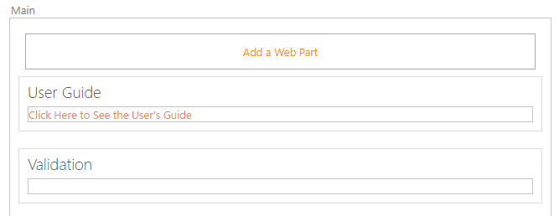

1. From the Edit Mode click on the “Add a Web Part” link, this will open the “Add a Web Part” interface, and then in the “Categories” panel on the left, scroll down and click on the “Media and Content” link, and then from the “Parts” panel on the right choose “Image Viewer”

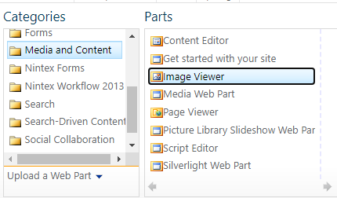

1. From the right-hand side of the Add a Web Part interface and click on the “Add” button (this will add the “Image Viewer Web Part” to the New Item page

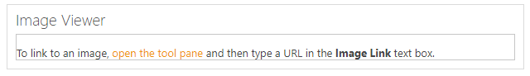

1. From the new Image Viewer Web Part, click on the drop down arrow (sometimes only visible when you click anywhere in the left side of the web part) and from the drop down menu click on the “Edit Web Part” link

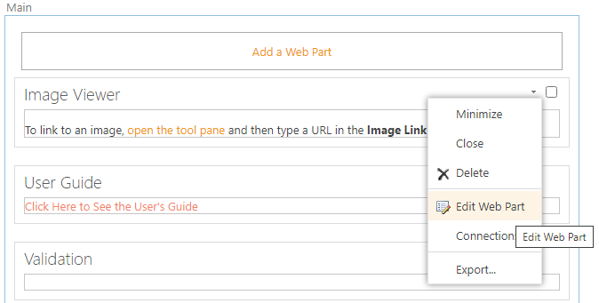

1. This will open the Image Viewer Web Part Configuration Menu (displays on the right)

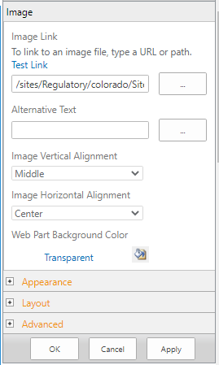

1. In the Image Viewer Web Part Configuration Menu in the Image panel make the following configurations:
   1. Image Link: https://ben.blackhillscorp.com/sites/Regulatory/Development%20Team%20Docs/Level12MenuItem.png
   2. Image Vertical Alignment: Middle
   3. Image Horizontal Alignment: Center

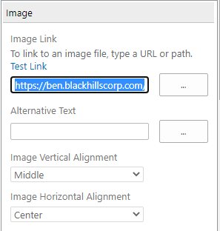

1. In the Image Viewer Web Part Configuration Menu click on the “Appearance” Menu item, and in the Appearance panel make the following configurations:
   1. Title: Form Examples
   2. Chrome Type: None

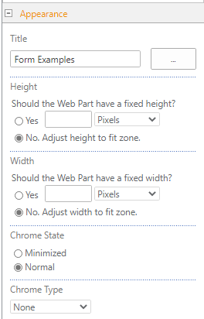

1. Finally scroll down and click on the “OK” button (this will save the changes you made)

Move the Code Web Parts to the Bottom of the Page

1. Now go to the Validation web part, click on the drop down arrow (sometimes only visible when you click anywhere in the left side of the web part) and from the drop down menu click on the “Edit Web Part” link

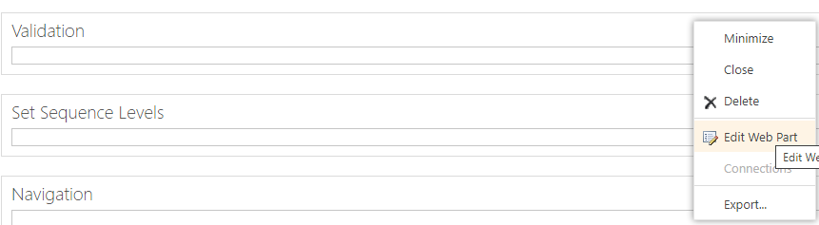

1. This will open the Validation web part Configuration Menu (displays on the right)

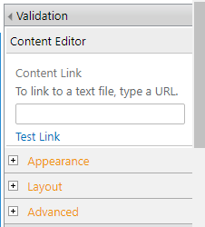

1. In the Validation web part Configuration Menu, click on the plus sign next to the “Layout” link, and in the Layout panel change the “Zone Index” value to 10, then click the OK button (this will move the validation web part to the bottom of the page)

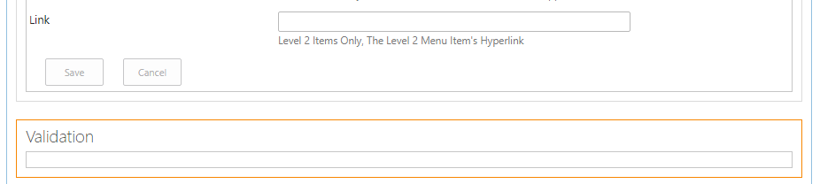

1. Now go to the Set Sequence Levels web part, click on the drop down arrow (sometimes only visible when you click anywhere in the left side of the web part) and from the drop down menu click on the “Edit Web Part” link

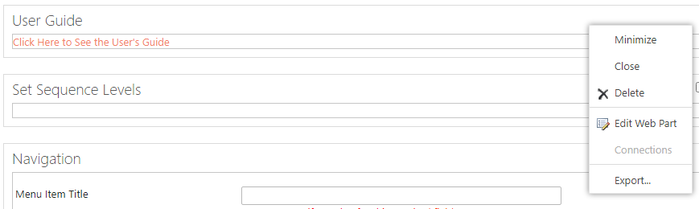

1. This will open the Set Sequence Levels web part Configuration Menu (displays on the right)

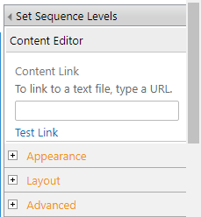

1. In the Set Sequence Levels web part Configuration Menu, click on the plus sign next to the “Layout” link, and in the Layout panel change the “Zone Index” value to 20, then click the OK button (this will move the Set Sequence Levels web part to the bottom of the page)

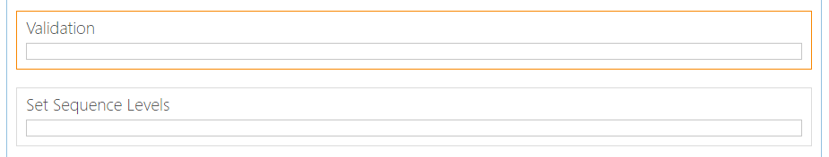

1. Now back at the New Item page, in the menu ribbon, click on the “Page” tab, and then the “Stop Editing” button, this will save the changes to the page made so far

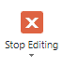

Test the New Form Page

1. From the Accordion Navigation list, click on the “New Item” link



1. This will open the “NewForm1” or “New Item” page

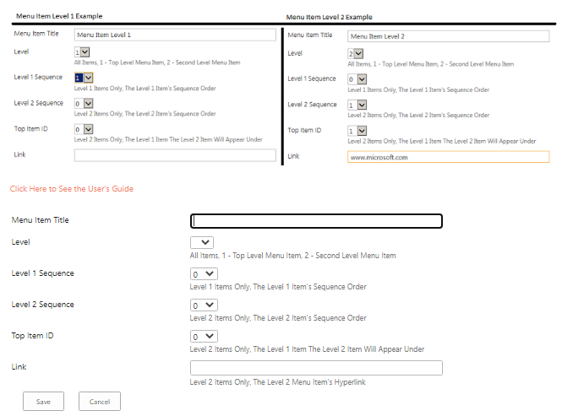

1. Perform the following Test and check for the following Test Results
2. Leave the “Menu Item Title” blank and then click on the Save Button



1. You should see the following pop-up message:

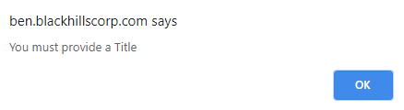

1. Click the “OK” button on the pop-up message (this will close the pop-up)
2. Add a “Menu Item Title” and then click on Save Button

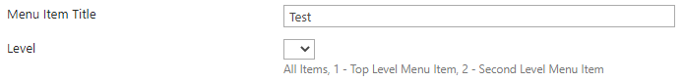

1. You should see the following pop-up message:

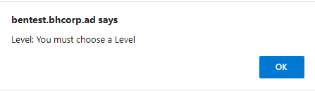

1. Click the “OK” button on the pop-up message (this will close the pop-up)
2. Set “Level” to “1”, Click on Save Button

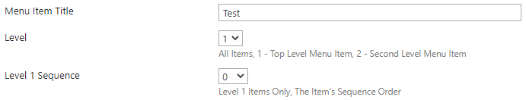

1. You should see the following pop-up message:

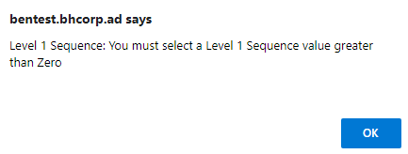

1. Click the “OK” button on the pop-up message (this will close the pop-up)
2. Set “Level 2 Sequence” to “1”, Click on Save Button

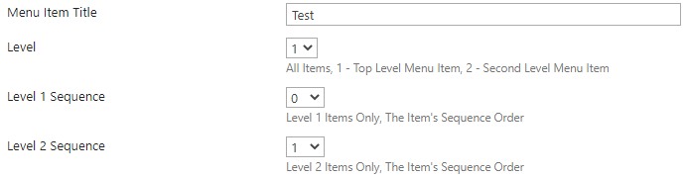

1. You should see the following pop-up message:

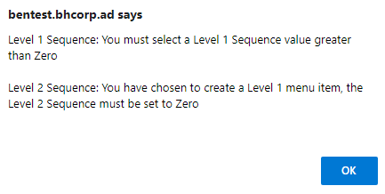

1. Click the “OK” button on the pop-up message (this will close the pop-up)
2. Set “Level 1 Sequence” to “1”, Click on Save Button

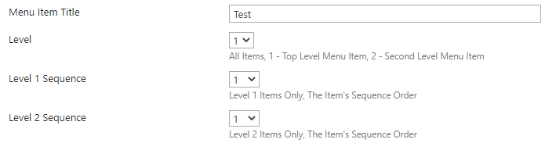

1. You should see the following pop-up message:

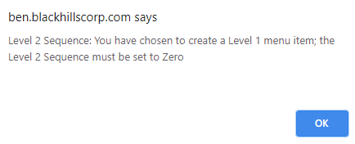

1. Click the “OK” button on the pop-up message (this will close the pop-up)
2. Set “Level 1” to “2”, Click on Save Button

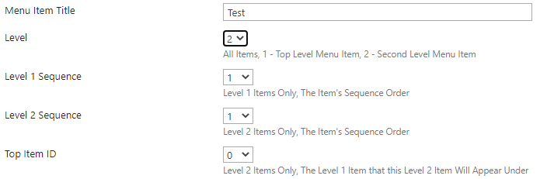

1. You should see the following pop-up message:

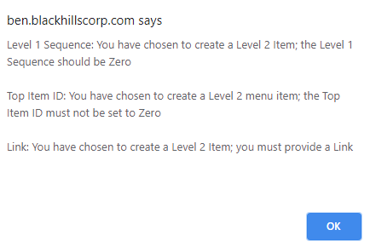

1. Click the “OK” button on the pop-up message (this will close the pop-up)
2. Set “Level 1 Sequence” to “0”, Click on Save Button

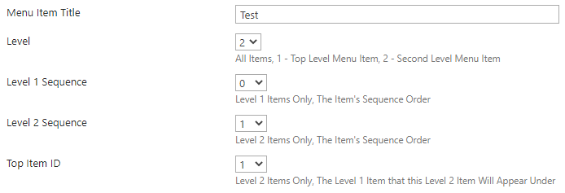

1. You should see the following pop-up message:

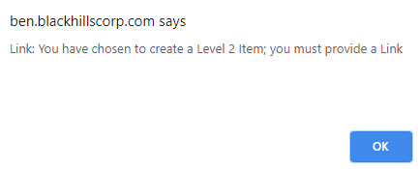

1. Click the “OK” button on the pop-up message (this will close the pop-up)
2. Set “Link” to “www.microsoft.com”, Click on Save Button

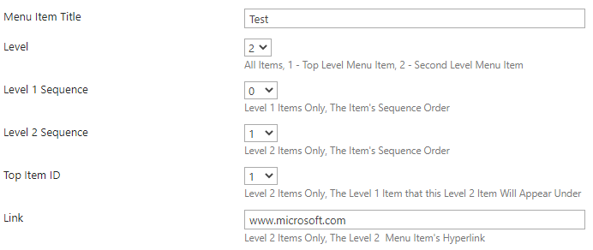

1. This will save the item
2. Now back at the Accordion Navigation list, click on the “New Item” link



1. You should now see the Level 1 Sequence and Level 2 Sequence have their values set above zero

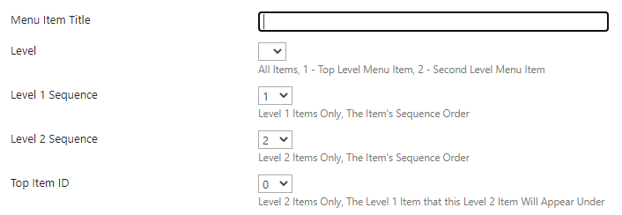

1. This update is provided by the code in the Set Sequence Level web part and it helps guide the user to avoid configuring a new item with a Level 1 or Level 2 sequence number that has already been assigned

# Edit Item Page

Create a New Item

1. From the Accordion Navigation list, click on the “New Item” link



1. Configure the New Item form as follows:

a. Menu Item Title: “Test Item Title 1”

b. Level: “1”

c. Level 1 Sequence: “1”

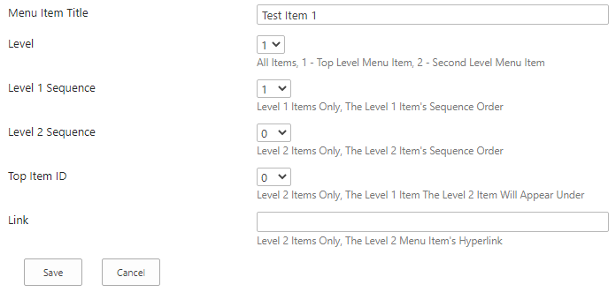

1. Click the OK button (this will validate and close the form)
2. Back at the List Page double click on the ellipsis to the right of the name of the item you just created (this will display the Context Menu)

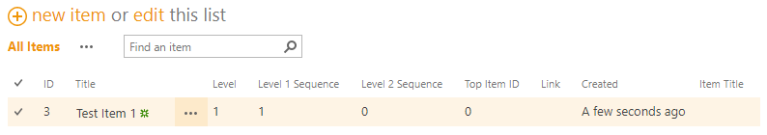

1. In the Context Menu click on the “Edit Item” menu item (this will open the item in Item Edit Mode)

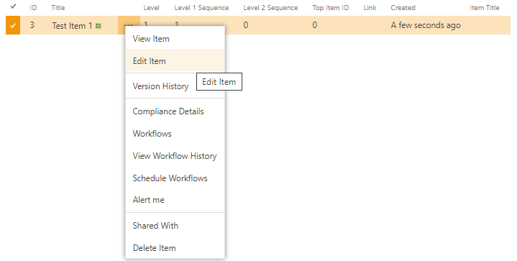

Create the Validation Web Part

1. With the New Item page in the Edit Mode click on the “Add a Web Part” link, this will open the “Add a Web Part” interface, and then in the “Categories” panel on the left, scroll down and click on the “Media and Content” link, and then from the “Parts” panel on the right choose “Content Editor”



1. From the right-hand side of the Add a Web Part interface and click on the “Add” button (this will add the Content Editor Web Part” to the New Item page



1. From the new Content Editor Web Part, click on the drop down arrow (sometimes only visible when you click anywhere in the left side of the web part) and from the drop down menu click on the “Edit Web Part” link



1. This will open the Content Editor Web Part Configuration Menu (displays on the right)



1. In the Content Editor Web Part Configuration Menu click on the “Appearance” Menu item, and in the Appearance panel make the following configurations:
   1. Title: Validation
   2. Chrome Type: None
2. Finally scroll down and click on the “OK” button (this will save the changes you made)
3. Now click in the Content Editor Web Part (which now has the title “Validation”), click where you see the words “Click here to add new content”



1. Now from the menu click on the “Edit Source” button, this will open a window for adding HTML and JavaScript Source Code



1. In the HTML Source window, past the code below:

<script language="javascript" src="/sites/Regulatory/SiteAssets/JavaScript/jquery-1.11.3.min.js"></script><script language="javascript" src="/sites/Regulatory/SiteAssets/Menu/jquery.SPServices-2014.02.js"></script><script language="javascript">

_spBodyOnLoadFunctionNames.push("validate"); {

}

function PreSaveAction() {

//*** Title

var strTitle = $("input[title='Menu Item Title Required Field']").val();

//*** Level

var ddlLevel = $("select[title='Level'] option:selected").text();

//*** Level 1 Sequence

var ddlLvl1Sequence = $("select[title='LVL1Sequence'] option:selected").text();

//*** Level 2 Sequence

var ddlLvl2Sequence = $("select[title='LVL2Sequence'] option:selected").text();

//*** Top Item ID

var ddlTopItemID = $("select[title='TopItemID'] option:selected").text();

//*** Link

var strLink = $("input[title='Link']").val();

return validateForm();

function validateForm(){

//*** General Validations: Ensure a Level Has Been Selected

if(ddlLevel == "1" || ddlLevel == "2"){

} else {

alert("Level: You must choose a Level");

}

//*** Validate: If Level 2 Item

if(ddlLevel == "2") {

var valTitle2 = "";

var valLink2 = "";

var valLvl1Sequence2 = "";

var valLvl2Sequence2 = "";

var valTopItemID2 = "";

var errorMsg = "";

//The Title Field Cannot be Empty

if(strTitle == "") {

errorMsg += "Menu Item Title: You must provide a Title\n\n";

valTitle2 = "false";

} else {

valTitle2 = "true";

}

//The Level 1 Sequence Field Value Should Be Zero

if(ddlLvl1Sequence == "0") {

valLvl1Sequence2 = "true";

} else {

errorMsg += "Level 1 Sequence: You have chosen to create a Level 2 Item; the Level 1 Sequence should be Zero\n\n";

valLvl1Sequence2 = "false";

}

//The Level 2 Sequence Must Not be Zero

if(ddlLvl2Sequence == "0") {

errorMsg += "Level 2 Sequence: You have chosen to create a Level 2 menu item; the Level 2 Sequence must not be set to Zero\n\n";

valLvl2Sequence2 = "false";

} else {

valLvl2Sequence2 = "true";

}

//The Top Item ID Must be Zero

if(ddlTopItemID == "0") {

errorMsg += "Top Item ID: You have chosen to create a Level 2 menu item; the Top Item ID must not be set to Zero\n\n";

valTopItemID2 = "false";

} else {

valTopItemID2 = "true";

}

//The Link Field Should Not Be Empty

if(strLink == "") {

errorMsg += "Link: You have chosen to create a Level 2 Item; you must provide a Link\n\n";

valLink2 = "false";

} else {

valLink2 = "true";

}

//Check All Validations and If All True Return True

if(valLink2 == "true" && valLvl1Sequence2 == "true" && valLvl2Sequence2 == "true" && valTopItemID2 == "true" && valTitle2 == "true") {

return true;

} else {

alert(errorMsg);

return false;

}

}

//*** Validate: If Level 1 Item

if(ddlLevel == "1") {

valTitle1 = "";

var valLink1 = "";

var valLvl1Sequence1 = "";

var valLvl2Sequence1 = "";

var valTopItemID1 = "";

var errorMsg = "";

//The Title Field Cannot be Empty

if(strTitle == "") {

errorMsg += "Menu Item Title: You must provide a Title\n\n";

valTitle1 = "false";

} else {

valTitle1 = "true";

}

//The Level 1 Sequence Field Value Should Not Be Zero

if(ddlLvl1Sequence == "0") {

errorMsg += "Level 1 Sequence: You must select a Level 1 Sequence value greater than Zero\n\n";

valLvl1Sequence1 = "false";

} else {

valLvl1Sequence1 = "true";

}

//The Level 2 Sequence Must be Zero

if(ddlLvl2Sequence == "0") {

valLvl2Sequence1 = "true";

} else {

errorMsg += "Level 2 Sequence: You have chosen to create a Level 1 menu item; the Level 2 Sequence must be set to Zero\n\n";

valLvl2Sequence1 = "false";

}

//The Top Item ID Must be Zero

if(ddlTopItemID == "0") {

valTopItemID1 = "true";

} else {

errorMsg += "Top Item ID: You have chosen to create a Level 1 menu item; the Top Item ID must be set to Zero\n\n";

valTopItemID1 = "false";

}

//The Link Field Should Be Empty

if(strLink == "") {

valLink1 = "true";

} else {

errorMsg += "Link: You have chosen to create a Level 1 Item; the Link field must be empty\n\n";

valLink1 = "false";

}

//Check All Validations and If All True Return True

if(valLink1 == "true" && valLvl1Sequence1 == "true" && valLvl2Sequence1 == "true" && valTopItemID1 == "true" && valTitle1 == "true") {

return true;

} else {

alert(errorMsg);

return false;

}

}

}

}

</script>

1. Now click on the “OK” button (this will save the added code)

Create the User Guide Web Part

1. From the New Item page click on the Site Actions cog and from the drop-down choose “Edit Page”, this will reopen the New Item page in the Edit Mode



1. From the Edit Mode click on the “Add a Web Part” link, this will open the “Add a Web Part” interface, and then in the “Categories” panel on the left, scroll down and click on the “Media and Content” link, and then from the “Parts” panel on the right choose “Content Editor”



1. From the right-hand side of the Add a Web Part interface and click on the “Add” button (this will add another Content Editor Web Part” to the New Item page



1. From the new Content Editor Web Part, click on the drop down arrow (sometimes only visible when you click anywhere in the left side of the web part) and from the drop down menu click on the “Edit Web Part” link



1. This will open the Content Editor Web Part Configuration Menu (displays on the right)



1. In the Content Editor Web Part Configuration Menu click on the “Appearance” Menu item, and in the Appearance panel make the following configurations:
   1. Title: User Guide
   2. Chrome Type: None
2. Finally scroll down and click on the “OK” button (this will save the changes you made)
3. Now click in the Content Editor Web Part (which now has the title “User Guide”), click where you see the words “Click here to add new content”



1. Now from the menu click on the “Edit Source” button, this will open a window for adding HTML and JavaScript Source Code



1. In the HTML Source window, past the code below:

<h4><a href="https://ben.blackhillscorp.com/sites/Regulatory/Development%20Team%20Docs/SharePoint%20Regulatory%20Accordion%20Menu%20List%20%E2%80%93%20User%20Guide.docx?Web=1">Click Here to See the User&#39;s Guide</a>

</h4>

1. Now click on the “OK” button (this will save th added code)

Create the Form Examples Web Part

1. From the New Item page click on the Site Actions cog and from the drop-down choose “Edit Page”, this will reopen the New Item page in the Edit Mode



1. From the Edit Mode click on the “Add a Web Part” link, this will open the “Add a Web Part” interface, and then in the “Categories” panel on the left, scroll down and click on the “Media and Content” link, and then from the “Parts” panel on the right choose “Image Viewer”



1. From the right-hand side of the Add a Web Part interface and click on the “Add” button (this will add the “Image Viewer Web Part” to the New Item page



1. From the new Image Viewer Web Part, click on the drop down arrow (sometimes only visible when you click anywhere in the left side of the web part) and from the drop down menu click on the “Edit Web Part” link



1. This will open the Image Viewer Web Part Configuration Menu (displays on the right)



1. In the Image Viewer Web Part Configuration Menu in the Image panel make the following configurations:
   1. Image Link: <https://ben.blackhillscorp.com/sites/Regulatory/Development%20Team%20Docs/Level12MenuItem.png>
   2. Image Vertical Alignment: Middle
   3. Image Horizontal Alignment: Center



1. In the Image Viewer Web Part Configuration Menu click on the “Appearance” Menu item, and in the Appearance panel make the following configurations:
   1. Title: Form Examples
   2. Chrome Type: None



1. Finally scroll down and click on the “OK” button (this will save the changes you made)

Move the Code Web Part to the Bottom of the Page

1. Now go to the Validation web part, click on the drop down arrow (sometimes only visible when you click anywhere in the left side of the web part) and from the drop down menu click on the “Edit Web Part” link



1. This will open the Validation web part Configuration Menu (displays on the right)



1. In the Validation web part Configuration Menu, click on the plus sign next to the “Layout” link, and in the Layout panel change the “Zone Index” value to 10, then click the OK button (this will move the validation web part to the bottom of the page)



1. Now back at the New Item page, in the menu ribbon, click on the “Page” tab, and then the “Stop Editing” button, this will save the changes to the page made so far



Test the Edit Form Page

1. From the List Page double click on the ellipsis to the right of the name of the item you just created (this will display the Context Menu)



1. In the Context Menu click on the “Edit Item” menu item (this will open the item in Item Edit Mode)



1. This will open the “EditForm1” or “Edit Item” page 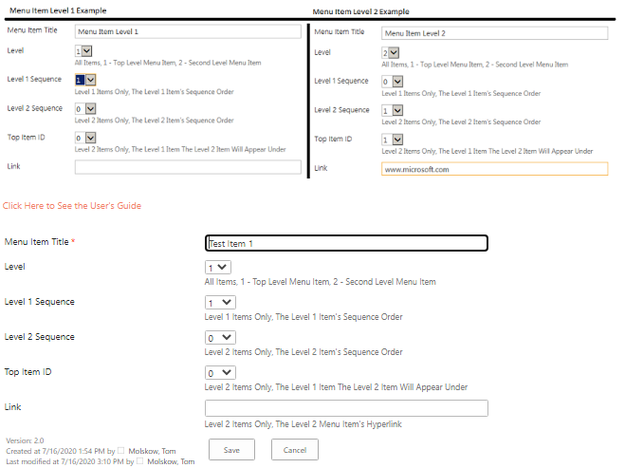
2. Perform the following Test and check for the following Test Results
3. Remove the “Menu Item Title”



1. Click on Save Button, you should see the following pop-up message:

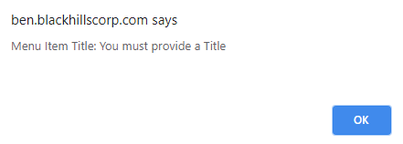

1. Click the “OK” button on the pop-up message (this will close the pop-up)
2. Renter the Title field text “Test”
3. Now set “Level 1 Sequence” to “0”

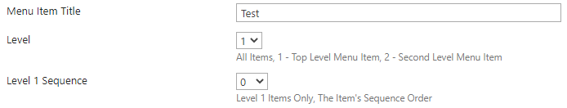

1. Click on Save Button, you should see the following pop-up message:



1. Click the “OK” button on the pop-up message (this will close the pop-up)
2. Set “Level 1 Sequence” back to “1”
3. Set “Level 2 Sequence” to “1”

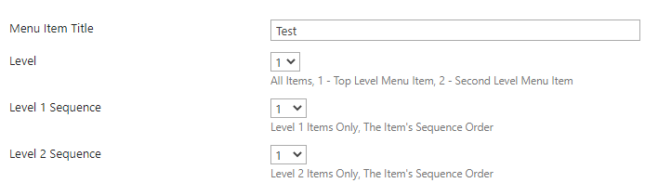

1. Click on Save Button, you should see the following pop-up message:

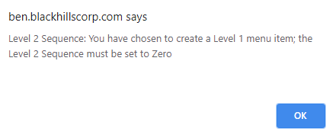

1. Click the “OK” button on the pop-up message (this will close the pop-up)
2. Set “Level 2 Sequence” back to “0”
3. Set “Top Item ID” to “1”

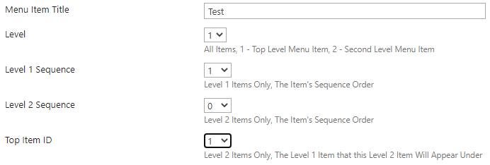

1. Click on Save Button, you should see the following pop-up message:

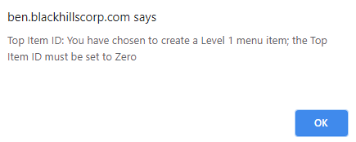

1. Click the “OK” button on the pop-up message (this will close the pop-up)
2. Set “Top Item ID” back to “0”
3. In the “Link” field add the text “www.microsoft.com”

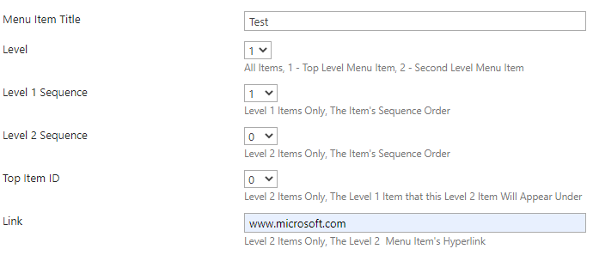

1. Click on Save Button, you should see the following pop-up message:

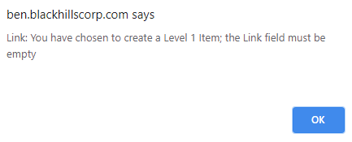

1. Click the “OK” button on the pop-up message (this will close the pop-up)
2. Set “Link” back to blank
3. Click the Form “Cancel” button

# Deploy the Custom Master Page

## Create the Custom Master Page

1. From the desktop, click on the SharePoint Designer icon



1. From the Sites menu, in the larger right panel, click on the “Open Site” button



1. From the “Open Sites” pop-up menu, in the “Site Name” field, input the name of the top site (in this example we will use the Regulatory site - <https://ben.blackhillscorp.com/sites/Regulatory/>), and then click the “Open” button

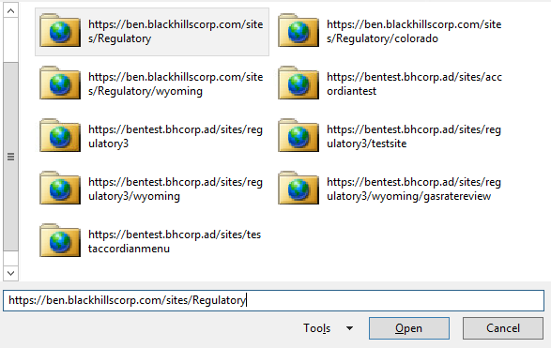

1. In the SharePoint Designer sites interface, in the “Navigation” panel (on the left), click on the “Master Pages” menu item (this will open the Master Pages navigation tab on the right)

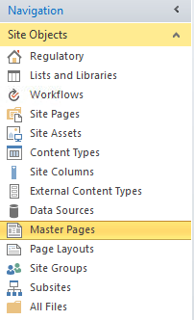

1. From the Master Pages tab on the right click the file named “Menu1.master” and from the context menu choose “Copy”

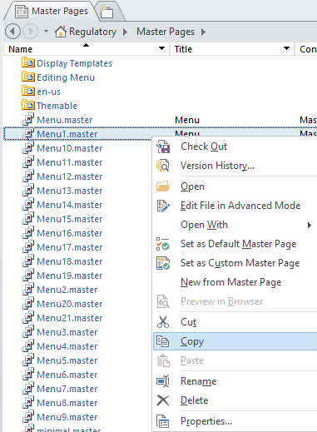

1. Now still in the Master Pages tab, right click in an empty white space (to the right of list items) and then from the pop-up context menu choose the item paste (this will paste the copy of the Menu.master file to the library)

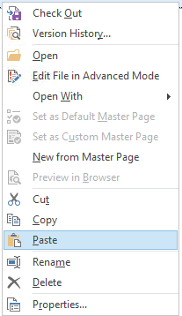

1. Right click on the new file which has been automatically named “Menu1_copy(1).master and from the pop-up context menu click on the link “Rename” (this will highlight the file name in the list view and enable it for editing)

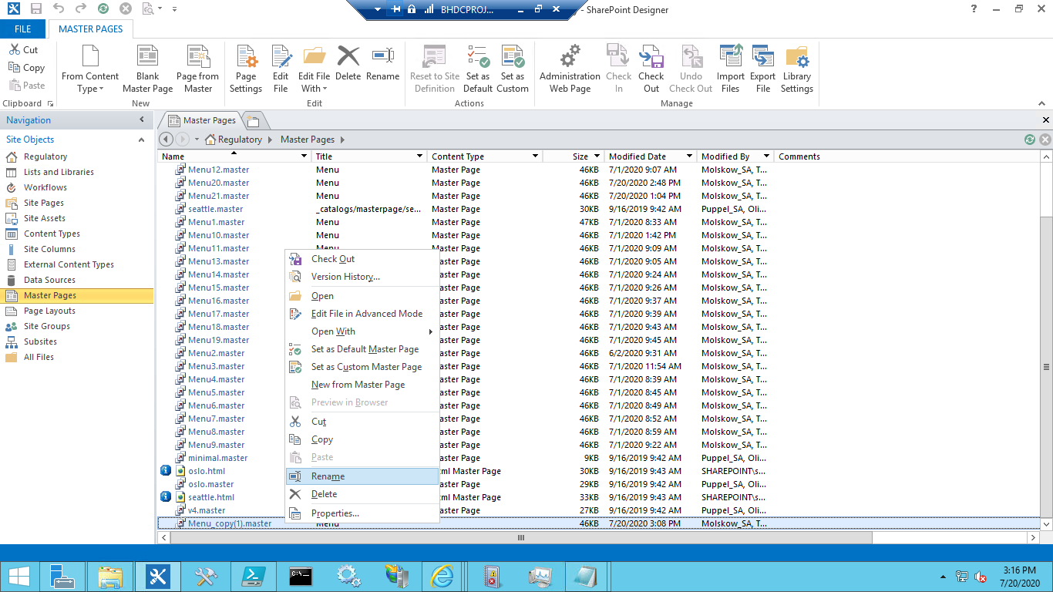

1. Now rename the item from Menu1_copy(1).master to [Top Site Name][Number], so for our example “Wyoming1.master”
   1. Before: 
   2. After: 
2. Now right click on the Wyoming1.master file and from the context menu choose the “Check Out” menu item (this will check out the file for editing)

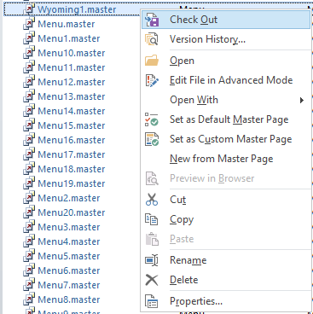

1. Now right click on the Wyoming1.master file again and from the context menu choose the “Edit File in Advanced Mode” menu item (this will open the Wyoming1.master page in the Advanced Edit Mode)

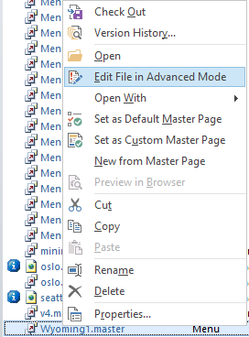

1. With the Wyoming1.master page opened in the Advanced Edit Mode, scroll down to or search to find the line of code shown below:

<SharePoint:CssRegistration Name="Themable/corev15.css" runat="server" />

1. Below this line insert the contents of the ListSliderStyles.css, as shown below:

<!-- List Slider Styles Start -->

<style type="text/css">

ol, ul, li {

padding: 0;

}

menu, nav, section { display: block; }

ol, ul { list-style: none; }

blockquote, q { quotes: none; }

blockquote:before, blockquote:after, q:before, q:after { content: ''; content: none; }

strong { font-weight: bold; }

table { border-collapse: collapse; border-spacing: 0; }

h1 { font-family: 'Merienda', 'Trebuchet MS', Verdana, sans-serif; font-size: 1em; line-height: 1.7em; margin-bottom: 20px; font-weight: bold; letter-spacing: -0.03em; color: #675d90; text-shadow: 2px 2px 0px rgba(255,255,255,0.65); text-align: center; }

#w { display: block; width: 400px; margin: 0 auto; margin-left: 0px; padding-top: 5px; }

/* nav menu styles */

#nav {

display: block;

width: 150px;

margin: 0 auto;

margin-left: 0px;

-webkit-box-shadow: 3px 2px 3px rgba(0,0,0,0.7);

-moz-box-shadow: 3px 2px 3px rgba(0,0,0,0.7);

box-shadow: 3px 2px 3px rgba(0,0,0,0.7);

}

#nav li { }

#nav > li > a {

display: block;

padding: 16px 12px;

font-size: 0.7em;

font-weight: bold;

color: #d4d4d4;

text-decoration: none;

border-bottom: 1px solid #212121;

background-color: #343434;

background: -webkit-gradient(linear, left top, left bottom, from(#948c6f), to(#292929));

background: -webkit-linear-gradient(top, #595959, #292929);

background: -moz-linear-gradient(top, #595959, #292929);

background: -ms-linear-gradient(top, #595959, #292929);

background: -o-linear-gradient(top, #595959, #292929);

background: linear-gradient(top, #595959, #292929);

}

#nav > li > a:hover, #nav > li > a.open {

color: #e9e9e9 !important;

border-bottom-color: #384f76;

background-color: #6985b5;

background: -webkit-gradient(linear, left top, left bottom, from(#6985b5), to(#456397));

background: -webkit-linear-gradient(top, #ff8c00, #456397);

background: -moz-linear-gradient(top, #ff8c00, #456397);

background: -ms-linear-gradient(top, #ff8c00, #456397);

background: -o-linear-gradient(top, #ff8c00, #456397);

background: linear-gradient(top, #ff8c00, #456397);

}

#nav li ul { display: none; background: #f09609; }

#nav li ul li a {

display: block;

background: none;

padding: 10px 0px;

padding-left: 10px;

font-size: 0.7em;

text-decoration: none;

font-weight: bold;

color: black;

border-bottom-style: solid;

border-bottom-color: orange;

/* text-shadow: 1px 1px 0px #ffffff; */

}

#nav li ul li a:hover {

color:white;

/* text-shadow: 1px 1px 0px #000000; */

background: -webkit-gradient(linear, left top, left bottom, from(#456397), to(#000000));

background: -webkit-linear-gradient(top, #456397, #000000);

background: -moz-linear-gradient(top, #456397, #000000);

background: -ms-linear-gradient(top, #456397, #000000);

background: -o-linear-gradient(top, #456397, #000000);

background: linear-gradient(top, #456397, #000000);

}

}

</style>

<!-- List Slider Styles Stop -->

1. Now scroll down to just below the last line of the code you inserted:

<!-- List Slider Styles Stop -->

1. Below this line insert the contents of the ListSliderCoreJavaScript.js, as shown below:

<!-- List Slider Core JavaScript Start -->

<script type="text/javascript">

if (typeof asyncDeltaManager != "undefined"){

asyncDeltaManager.add_endRequest(loadJQueryFirstOrExecuteDirectly);

} else {

loadJQueryFirstOrExecuteDirectly();

};

function loadJQueryFirstOrExecuteDirectly(){

if(window.jQuery === undefined) {

var script = document.createElement("script");

script.type = "text/javascript";

script.onload = function(){

stickyHeaders();

};

(document.getElementsByTagName("head")[0]).appendChild(script);

script.src = "//code.jquery.com/jquery-3.2.1.min.js";

} else {

stickyHeaders();

};

}

function stickyHeaders() {

window.SHListContainer = [];

function findListsAndAttachHandlers() {

jQuery("tr:has(>th[class*=ms-vh]):visible").closest("table").each(function(){

var list = new List(jQuery(this));

window.SHListContainer.push(list);

list.init();

list.webpart.data("stickyHeaderData",list);

jQuery("#s4-workspace").on("scroll.stickyHeaders", {elem: list}, function (event) {

event.data.elem.update();

});

jQuery(window).on("resize.stickyHeaders", {elem: list}, function (event) {

setTimeout(function(){

event.data.elem.setWidth();

event.data.elem.update();

},50);

});

if(list.fixedHeight || list.fixedWidth){

list.webpart.on("scroll.stickyHeaders", {elem: list}, function(event){

event.data.elem.update();

});

};

if(typeof ReRenderListView == "function") {

var ReRenderListView_old = ReRenderListView;

ReRenderListView = function(b, l, e){

ReRenderListView_old(b, l, e);

jQuery("#WebPart" + b.wpq).data("stickyHeaderData").init();

};

}

});

var ribbonHeight = 0;

g_workspaceResizedHandlers.push(function () {

var newRibbonHeight = jQuery("#RibbonContainer").height();

if(ribbonHeight !== newRibbonHeight) {

jQuery(window.SHListContainer).each(function(){

this.s4OffsetTop = jQuery("#s4-workspace").offset().top;

this.update();

});

ribbonHeight = newRibbonHeight;

}

});

var ExpCollGroup_old = ExpCollGroup;

ExpCollGroup = function (c, F, y, w) {

ExpCollGroup_old(c, F, y, w);

var element = ("#tbod" + c + "_, #titl" + c);

var interval = setInterval(function () {

if(jQuery(element).attr("isloaded") == "true" || typeof jQuery(element).attr("isloaded") == "undefined") {

setTimeout(function(){

jQuery(element).closest("[id^=WebPartWPQ]").data("stickyHeaderData").init();

},200);

clearInterval(interval);

}

}, 100);

};

};

function List(list) {

this.list = list;

this.webpart = jQuery(this.list.closest("div[id^=WebPartWPQ]")[0] || this.list[0]);

this.fixedHeight = ["","auto","100%"].indexOf(this.webpart.prop("style")["height"]) + 1 ? false : true;

this.fixedWidth = ["","auto","100%"].indexOf(this.webpart.prop("style")["width"]) + 1 ? false : true;

this.init = function() {

this.s4OffsetTop = jQuery("#s4-workspace").offset().top;

this.list = jQuery.contains(document.documentElement, this.list[0]) ? jQuery(this.list) : jQuery(this.webpart.find(".ms-listviewtable").last()[0] || this.webpart.find("> table")[0]);

this.listType = this.list.find("tbody[id^=GroupByCol]").length ? "GroupedList" : this.list.hasClass("ms-listviewgrid") ? "Grid" : typeof this.list.closest("div[id^=WebPartWPQ]")[0] == "undefined" ? "SysList" : "NormalList";

this.firstRow = this.list.find("thead").length ? (this.listType == "GroupedList" ? this.list.find("tbody[isloaded=true]:visible > tr").first() : this.list.find("> tbody > tr:nth-child(1)")) : this.list.find("> tr:nth-child(2), > tbody > tr:nth-child(2)");

this.prevHeight = this.listType == "Grid" ? this.list.parent().closest(".ms-listviewtable")[0].offsetTop : this.list[0].offsetTop; //little bug in Edge: value wrong after pagination

this.sticky = this.webpart.find("tr:has(>th[class*=ms-vh]):visible").first();

this.stickyHeight = this.sticky.outerHeight();

this.webpartHeight = this.webpart.height();

if(this.listType == "Grid") {

this.list.css({

"table-layout": "fixed",

"width" : "auto"

});

jQuery("#spgridcontainer_" + this.webpart.attr("id").substr(7))[0].jsgrid.AttachEvent(SP.JsGrid.EventType.OnCellEditCompleted, (function(caller){

return function(){

caller.setWidth.apply(caller, arguments);

};

})(this));

this.sticky.find("a").on("click", this.fixSortFunctionality);

jQuery("th").hover(function(e){

if(jQuery(e.target).parents(".stickyHeader").length > 0){

jQuery(e.target).find(".clip9x6").css("visibility", e.type == "mouseenter" ? "visible" : "hidden").find("> img").show();

};

}).on("mouseleave", function(e){

if(jQuery(e.target).parents(".stickyHeader").length > 0){

jQuery(e.target).find(".clip9x6").css("visibility", "hidden").find("> img").show();

};

})

};

if(this.sticky.find("th:last-child.ms-vh-icon:has(>span.ms-addcolumn-span)").hide().length) {

this.list.addClass("addPadding");

};

this.setWidth();

this.update();

};

this.fixSortFunctionality = function(e){

if(jQuery(e.target).parents(".stickyHeader").length > 0){

var clvp = jQuery(e.target).closest(".ms-listviewtable:not(.ms-listviewgrid)")[0].clvp;

var strHash = ajaxNavigate.getParam("InplviewHash" + clvp.wpid);

var result = {};

strHash.split("-").forEach(function(part) {

var item = part.split("=");

result[item[0]] = decodeURIComponent(item[1]);

});

var prevSortField = result.SortField;

result.SortField = jQuery(e.target).closest("th")[0].thColumnKey;

result.SortDir = prevSortField != result.SortField ? "Asc" : result.SortDir == "Asc" ? "Desc" : "Asc";

var params = $.param(result);

InitGridFromView(clvp.ctx.view, true);

clvp.strHash = params.replace(/&/g, "-");

clvp.fRestore = true;

clvp.RefreshPagingEx("?" + params, true, null);

}

};

this.setWidth = throttleUpdates(function() {

this.sticky.css({

"position": "static",

"display" : "table-row"

});

var stickyChildren = this.sticky.children("th");

var firstRowChildren = this.firstRow.children("td");

jQuery.each([stickyChildren, firstRowChildren], function(){

jQuery(this).css("min-width", 0);

});

var stickyChildrenWidths = [], firstRowChildrenWidths = [];

for(var i=0; i < stickyChildren.length; i++){

stickyChildrenWidths.push(jQuery(stickyChildren[i]).width());

firstRowChildrenWidths.push(jQuery(firstRowChildren[i]).width());

};

for(var i=0; i < stickyChildren.length; i++){

jQuery(stickyChildren[i]).css("min-width", stickyChildrenWidths[i]);

jQuery(firstRowChildren[i]).css("min-width", firstRowChildrenWidths[i]);

};

this.sticky.css("position", this.sticky.hasClass("stickyHeader") ? "fixed" : "static")

});

this.update = throttleUpdates(function() {

if(this.fixedWidth) {

return;

};

this.webpartOffsetTop = this.webpart.offset().top;

if(this.firstRow.length && (this.webpartOffsetTop + this.webpartHeight - this.s4OffsetTop > 0 && (this.webpartOffsetTop - this.s4OffsetTop + this.prevHeight < 0 || this.webpart.scrollTop() > this.prevHeight))){

if(!this.sticky.hasClass("stickyHeader")) {

this.toggleSticky(true);

};

this.sticky.css({

"left": this.webpart.offset().left,

"top" : (!this.fixedHeight || this.webpartOffsetTop < (this.s4OffsetTop + 2)) ? (this.s4OffsetTop + 2) : (this.webpartOffsetTop)

})

} else {

if(this.sticky.hasClass("stickyHeader")) {

this.toggleSticky(false)

}

}

});

this.toggleSticky = function(mode){

if(this.listType == "SysList"){

var headerChildren = (this.listType == "GroupedList") ? this.list.find("tbody[id^=titl]").first().find("td") : this.firstRow.children("td");

var _stickyHeight = this.stickyHeight;

headerChildren.each(function(){

jQuery(this).css("padding-top", parseInt(jQuery(this).css("padding-top")) + _stickyHeight * (mode == true ? 1 : -1));

})

} else {

mode ? this.list.css("padding-top", this.stickyHeight) : this.list.css("padding-top", 0);

};

this.sticky.css({

"position": mode ? "fixed" : "static",

"display" : mode ? "none" : "table-row"

});

mode ? this.sticky.addClass("stickyHeader").slideDown(200) : this.sticky.removeClass("stickyHeader");

}

};

function throttleUpdates(t,e){function u(){function e(){n=+new Date,t.apply(u,d)}var u=this,a=+new Date-n,d=arguments;i&&clearTimeout(i),a>r?e():i=setTimeout(e,r-a)}var i,n=0,r=50;return jQuery.guid&&(u.guid=t.guid=t.guid||jQuery.guid++),u}

(function () {

if(!jQuery("#MSOLayout_InDesignMode").val() && !jQuery("#_wikiPageMode").val()){

if(jQuery.inArray("spgantt.js", g_spPreFetchKeys) > -1) {

ExecuteOrDelayUntilScriptLoaded(function () {

setTimeout(function () {

findListsAndAttachHandlers();

}, 0)

}, "spgantt.js")

} else {

findListsAndAttachHandlers();

};

if(typeof _spWebPartComponents != "undefined" && Object.keys(_spWebPartComponents).length == 1) {

ExecuteOrDelayUntilScriptLoaded(function(){

var ShowContextRibbonSections = (function fn(){

SP.Ribbon.WebPartComponent.registerWithPageManager({editable: true, isEditMode: false, allowWebPartAdder: false});

SP.Ribbon.WebPartComponent.get_instance().selectWebPart(jQuery("#MSOZoneCell_" + Object.keys(_spWebPartComponents))[0], true);

return fn

})();

ExecuteOrDelayUntilScriptLoaded(function(){

var DeselectAllWPItems_old = DeselectAllWPItems;

DeselectAllWPItems = function () {

DeselectAllWPItems_old();

setTimeout(function () {

ShowContextRibbonSections()

}, 25)

}

}, "core.js")

}, "sp.ribbon.js")

};

var style = ".stickyHeader {" +

"border: 1px solid grey;" +

"background-color: white;" +

"box-shadow: 0 0 6px -2px black;" +

"z-index: 1;" +

"}" +

".stickyHeader > th {" +

"position: relative;" +

"}" +

".ms-listviewtable th .ms-core-menu-box {" +

"top: auto !important;" +

"left: auto !important;" +

"}" +

".stickyHeader th:not([id^=spgridcontainer]) {" +

"border-bottom: 0 !important;" +

"}" +

".ms-listviewtable.addPadding {" +

"padding-right: 26px !important;" +

"}";

var div = jQuery("<div />", {

html: "&shy;<style>" + style + "</style>"

}).appendTo("body");

}

})()

}

</script>

<!-- List Slider Core JavaScript End -->

1. Now scroll down to just below the last line of the code you inserted:

<!-- List Slider Core JavaScript End -->

1. Below this line insert the contents of the ListSliderREST.js, as shown below:

<!-- List Slider REST Start -->

<script type="text/javascript" src="/sites/Regulatory/SiteAssets/JavaScript/jquery-1.11.3.min.js"></script>

<script type="text/javascript" src="/sites/Regulatory/SiteAssets/JavaScript/jquery.SPServices-2014.02.js"></script>

<script type="text/javascript">

$(function () {

$.ajax({

url: "/sites/regulatory/Wyoming/_api/web/lists/GetByTitle('Navigation')/items?$orderby=LVL2Sequence",

type: "GET",

headers: {

"accept": "application/json;odata=verbose"

},

}).success(function (data) {

var listItemInfo = '';

listItemInfo += "<nav><ul id='nav'>"

//Level 1 LVL1Sequence 1

$.each(data.d.results, function (key, value) {

if(value.Level == 1){

if(value.LVL1Sequence == 1){

listItemInfo += "<li><a href='#' style='padding-left:24px;'>" + value.Title + "</a><ul>";

}

}

});

//TopItemID 1 Level 2 LVL2Sequence All

$.each(data.d.results, function (key, value) {

if(value.Level == 2){

if(value.TopItemID == 1){

listItemInfo += "<li><a href='" + value.Link + "'>" + value.Title + "</a></li>";

}

}

});

//Level 1 LVL1Sequence 2

$.each(data.d.results, function (key, value) {

if(value.Level == 1){

if(value.LVL1Sequence == 2){

listItemInfo += "</ul></li><li><a href='#' style='padding-left:24px;'>" + value.Title + "</a><ul>";

}

}

});

//TopItemID 2 Level 2 LVL2Sequence All

$.each(data.d.results, function (key, value) {

if(value.Level == 2){

if(value.TopItemID == 2){

listItemInfo += "<li><a href='" + value.Link + "'>" + value.Title + "</a></li>";

}

}

});

//Level 1 LVL1Sequence 3

$.each(data.d.results, function (key, value) {

if(value.Level == 1){

if(value.LVL1Sequence == 3){

listItemInfo += "</ul></li><li><a href='#' style='padding-left:24px;'>" + value.Title + "</a><ul>";

}

}

});

//TopItemID 3 Level 2 LVL2Sequence All

$.each(data.d.results, function (key, value) {

if(value.Level == 2){

if(value.TopItemID == 3){

listItemInfo += "<li><a href='" + value.Link + "'>" + value.Title + "</a></li>";

}

}

});

//Level 1 LVL1Sequence 4

$.each(data.d.results, function (key, value) {

if(value.Level == 1){

if(value.LVL1Sequence == 4){

listItemInfo += "</ul></li><li><a href='#' style='padding-left:24px;'>" + value.Title + "</a><ul>";

}

}

});

//TopItemID 4 Level 2 LVL2Sequence All

$.each(data.d.results, function (key, value) {

if(value.Level == 2){

if(value.TopItemID == 4){

listItemInfo += "<li><a href='" + value.Link + "'>" + value.Title + "</a></li>";

}

}

});

//Level 1 LVL1Sequence 5

$.each(data.d.results, function (key, value) {

if(value.Level == 1){

if(value.LVL1Sequence == 5){

listItemInfo += "</ul></li><li><a href='#' style='color:orange;'>" + value.Title + "</a><ul>";

}

}

});

//TopItemID 5 Level 2 LVL2Sequence All

$.each(data.d.results, function (key, value) {

if(value.Level == 2){

if(value.TopItemID == 5){

listItemInfo += "<li><a href='" + value.Link + "'>" + value.Title + "</a></li>";

}

}

});

//Level 1 LVL1Sequence 6

$.each(data.d.results, function (key, value) {

if(value.Level == 1){

if(value.LVL1Sequence == 6){

listItemInfo += "</ul></li><li><a href='#'>" + value.Title + "</a><ul>";

}

}

});

//TopItemID 6 Level 2 LVL2Sequence All

$.each(data.d.results, function (key, value) {

if(value.Level == 2){

if(value.TopItemID == 6){

listItemInfo += "<li><a href='" + value.Link + "'>" + value.Title + "</a></li>";

}

}

});

//Level 1 LVL1Sequence 7

$.each(data.d.results, function (key, value) {

if(value.Level == 1){

if(value.LVL1Sequence == 7){

listItemInfo += "</ul></li><li><a href='#'>" + value.Title + "</a><ul>";

}

}

});

//TopItemID 7 Level 2 LVL2Sequence All

$.each(data.d.results, function (key, value) {

if(value.Level == 2){

if(value.TopItemID == 7){

listItemInfo += "<li><a href='" + value.Link + "'>" + value.Title + "</a></li>";

}

}

});

//Level 1 LVL1Sequence 8

$.each(data.d.results, function (key, value) {

if(value.Level == 1){

if(value.LVL1Sequence == 8){

listItemInfo += "</ul></li><li><a href='#'>" + value.Title + "</a><ul>";

}

}

});

//TopItemID 8 Level 2 LVL2Sequence All

$.each(data.d.results, function (key, value) {

if(value.Level == 2){

if(value.TopItemID == 8){

listItemInfo += "<li><a href='" + value.Link + "'>" + value.Title + "</a></li>";

}

}

});

//Level 1 LVL1Sequence 9

$.each(data.d.results, function (key, value) {

if(value.Level == 1){

if(value.LVL1Sequence == 9){

listItemInfo += "</ul></li><li><a href='#'>" + value.Title + "</a><ul>";

}

}

});

//TopItemID 9 Level 2 LVL2Sequence All

$.each(data.d.results, function (key, value) {

if(value.Level == 2){

if(value.TopItemID == 9){

listItemInfo += "<li><a href='" + value.Link + "'>" + value.Title + "</a></li>";

}

}

});

//Level 1 LVL1Sequence 10

$.each(data.d.results, function (key, value) {

if(value.Level == 1){

if(value.LVL1Sequence == 10){

listItemInfo += "</ul></li><li><a href='#'>" + value.Title + "</a><ul>";

}

}

});

//TopItemID 10 Level 2 LVL2Sequence All

$.each(data.d.results, function (key, value) {

if(value.Level == 2){

if(value.TopItemID == 10){

listItemInfo += "<li><a href='" + value.Link + "'>" + value.Title + "</a></li>";

}

}

});

//Level 1 LVL1Sequence 11

$.each(data.d.results, function (key, value) {

if(value.Level == 1){

if(value.LVL1Sequence == 11){

listItemInfo += "</ul></li><li><a href='#'>" + value.Title + "</a><ul>";

}

}

});

//TopItemID 11 Level 2 LVL2Sequence All

$.each(data.d.results, function (key, value) {

if(value.Level == 2){

if(value.TopItemID == 11){

listItemInfo += "<li><a href='" + value.Link + "'>" + value.Title + "</a></li>";

}

}

});

//Level 1 LVL1Sequence 12

$.each(data.d.results, function (key, value) {

if(value.Level == 1){

if(value.LVL1Sequence == 12){

listItemInfo += "</ul></li><li><a href='#'>" + value.Title + "</a><ul>";

}

}

});

//TopItemID 12 Level 2 LVL2Sequence All

$.each(data.d.results, function (key, value) {

if(value.Level == 2){

if(value.TopItemID == 12){

listItemInfo += "<li><a href='" + value.Link + "'>" + value.Title + "</a></li>";

}

}

});

//Level 1 LVL1Sequence 13

$.each(data.d.results, function (key, value) {

if(value.Level == 1){

if(value.LVL1Sequence == 13){

listItemInfo += "</ul></li><li><a href='#'>" + value.Title + "</a><ul>";

}

}

});

//TopItemID 13 Level 2 LVL2Sequence All

$.each(data.d.results, function (key, value) {

if(value.Level == 2){

if(value.TopItemID == 13){

listItemInfo += "<li><a href='" + value.Link + "'>" + value.Title + "</a></li>";

}

}

});

//Level 1 LVL1Sequence 14

$.each(data.d.results, function (key, value) {

if(value.Level == 1){

if(value.LVL1Sequence == 14){

listItemInfo += "</ul></li><li><a href='#'>" + value.Title + "</a><ul>";

}

}

});

//TopItemID 14 Level 2 LVL2Sequence All

$.each(data.d.results, function (key, value) {

if(value.Level == 2){

if(value.TopItemID == 14){

listItemInfo += "<li><a href='" + value.Link + "'>" + value.Title + "</a></li>";

}

}

});

//Level 1 LVL1Sequence 15

$.each(data.d.results, function (key, value) {

if(value.Level == 1){

if(value.LVL1Sequence == 15){

listItemInfo += "</ul></li><li><a href='#'>" + value.Title + "</a><ul>";

}

}

});

//TopItemID 15 Level 2 LVL2Sequence All

$.each(data.d.results, function (key, value) {

if(value.Level == 2){

if(value.TopItemID == 15){

listItemInfo += "<li><a href='" + value.Link + "'>" + value.Title + "</a></li>";

}

}

});

listItemInfo += "</ul></li></ul></nav>"

return $("#w").html(listItemInfo);;

});

failure(function (data) {

alert("Failure");

});

});

</script>

<!-- List Slider REST End -->

1. Now scroll to or search to find the line of code shown below:

url: "/sites/regulatory/Colorado/_api/web/lists/GetByTitle('Navigation')/items?$orderby=LVL2Sequence"

1. Once you have found this line of code change the yellow highlighted portion to the value that matches your top site’s base location string, so for example:
   1. Wyoming Top Site URL:

<https://ben.blackhillscorp.com/sites/Regulatory/wyoming/Pages/default.aspx>

* 1. Wyoming Top Site Base Location String:

/sites/Regulatory/wyoming/

* 1. New line of code:

url: "/sites/Regulatory/wyoming/_api/web/lists/GetByTitle('Navigation')/items?$orderby=LVL2Sequence"

1. Now in the same line of code change the green highlighted portion from the value “Navigation” to the value “Accordion Navigation”, so for example:
   1. From this:

url: "/sites/regulatory/Colorado/_api/web/lists/GetByTitle('Navigation')/items?$orderby=LVL2Sequence"

* 1. To this:

url: "/sites/regulatory/Colorado/_api/web/lists/GetByTitle('Accordion Navigation')/items?$orderby=LVL2Sequence"

1. Now scroll down to just below the last line of the code you inserted:

<!-- List Slider REST End -->

1. Below this line insert the contents of the ListSliderOpenClose.js, as shown below:

<!-- List Slider Open and Close Start -->

<script language="javascript" src="https://ben.blackhillscorp.com/sites/Regulatory/SiteAssets/JavaScript/jquery-1.11.3.min.js"></script>

<script language="javascript" src="https://ben.blackhillscorp.com/sites/Regulatory/SiteAssets/JavaScript/jquery.SPServices-2014.02.js"></script>

<script type="text/javascript">

$(document).ready(function(){

$("#w").on('click','#nav > li > a',function(e){

if($(this).parent().has("ul")) {

e.preventDefault();

}

if(!$(this).hasClass("open")) {

//Hide Any Open Menus and Remove All Other Classes

$("#nav li ul").slideUp(350);

$("#nav li a").removeClass("open");

//Open A New Menu and Add the Open Class

$(this).next("ul").slideDown(350);

$(this).addClass("open");

}

//Close the New Menu and Remove the Open Class

else if($(this).hasClass("open")) {

$(this).removeClass("open");

$(this).next("ul").slideUp(350);

}

});

});

</script>

<!-- List Slider Open and Close End -->

1. Now, in the Menu Ribbon, in the top left-hand corner, click on the save button (this will save your changes to the Master Page)



1. In the Tab Menu click on the “Master Pages” link (this will return you to the Master Pages list page)



1. Back at the Master Pages list page, find the Wyoming1.master file, right click on it, and from the pop-up context menu choose (this will open the Check In pop-up window)

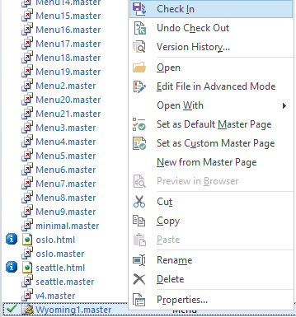

1. At the Check In pop-up window, in the “What type of version do you want to check in?” section, choose “Publish a major version” and then click the “OK” button (this will check in and publish the Master Page)

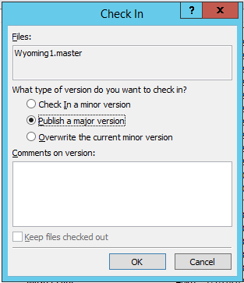

Deploy the Custom Master Page

1. Go to the site you will be deploying the custom Master Page to, click on the Site Actions Cog, and from the drop down, choose Site Settings (this will open the Site Settings page)

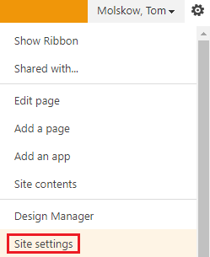

1. From the Site Settings page, under the “Look and Feel” heading, click on the “Master Page” link (this will open the Site Master Page Settings page)



1. Now with the Site Master Page Settings page make the following configurations, and then click the “OK” button (this will return you to the Site Settings page):
   1. Site Master Page: Wyoming1

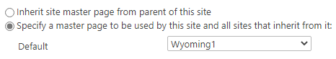

* 1. System Master Page: Wyoming1

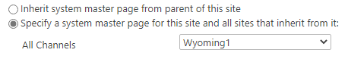

# Configure the Accordion Menu

Please see the document “[SharePoint Regulatory Accordion Menu List – User Guide](https://ben.blackhillscorp.com/sites/Regulatory/Development%20Team%20Docs/SharePoint%20Regulatory%20Accordion%20Menu%20List%20%E2%80%93%20User%20Guide.docx?Web=1)” for complete instructions on Configuring the Accordion Menu.

# Remove the Standard Navigation (Optional Step)

1. Note: This step is only necessary if don’t wish to have both the Accordion Menu and the Standard SharePoint Navigation active at the same time on the same site.
2. From the site you have deployed the Accordion Menu solution to click on the site actions cog, and from the drop down choose the “Site Settings” menu item.

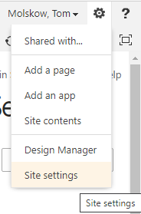

1. From the Site Settings page, under the “Look and Feel” header choose the “Navigation” link.

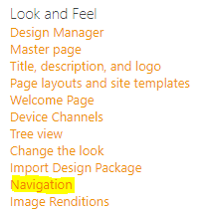

1. In the “Navigation Settings” page make the following changes:
   1. Current Navigation:
      1. Structural Navigation: Display only the navigation items below the current site – Yes
      2. Show Subsites – No
      3. Show Pages – No

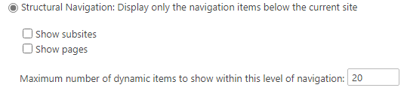

* 1. Structural Navigation: Sorting – Sort Manually

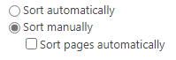

* 1. Structural Navigation: Editing and Sorting – Delete All Headings and Links

1. Now then click the “OK” button, this will save the changes and return you to the Site Settings page
2. Back at the List go ahead and click on the Test item you just created
3. Now in the